Welcome to my Homepage

My name is Angela Regina Otto

[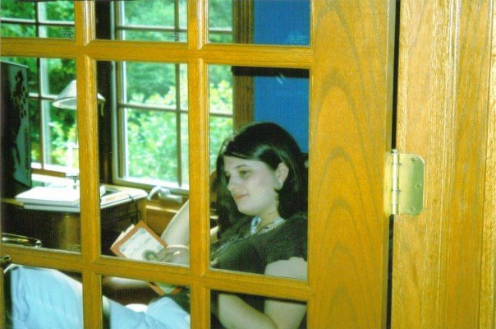](http://www.facebook.com/photo.php?pid=31426888&id=37701607&op=1&view=all&subj=588091549)

This page was last updated April 9th, 2008

Here are a few of my favorite links:

[www.facebook.com](http://www.facebook.com)

[www.youtube.com](http://www.youtube.com)

[www.wikipedia.org](http://www.wikipedia.org)

[www.neopets.com](http://www.neopets.com)

[www.fanpop.com](http://www.fanpop.com)

[www.tv.com](http://www.tv.com)

Here is a copy of my resume

* Disclaimer: The views and opinions expressed in this page are strictly those of the page author. The contents of this page have not been reviewed or approved by SIUE.
* Page URL:www.siue.edu/~aotto